Types of Machine Learning:
1. Supervised
2. Unsupervised
3.Reinforcement

In supervised machine learning we provide labelled data and ML-algorithm learns from it.

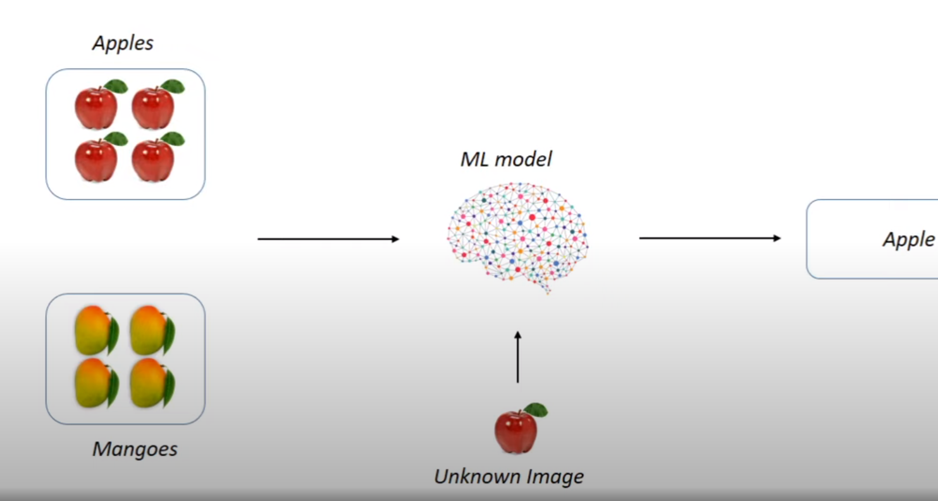
in unsupervised learning ML algorithm learns from unlabelled data
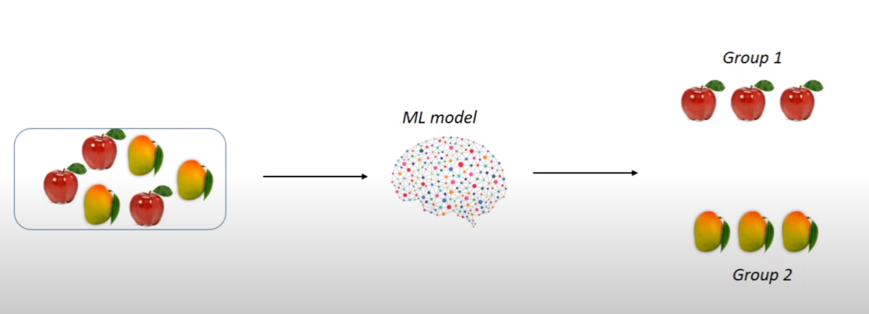
grouping will based upon common patterns in data provides and based upon similarities the algo will classify them in different groups

Reinforcement learning is an area of machine learning in which intelligent agents takes action in an environment to maximise it’s rewards
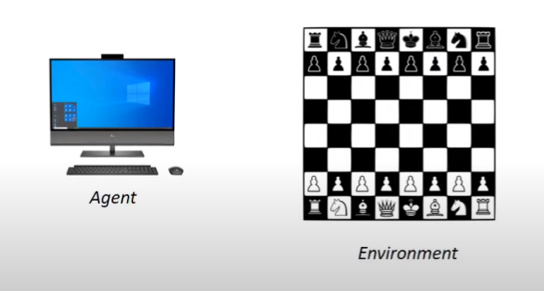
consist of 4 parts:
1.Agent
2.Environment
3.Action
4.Reward

about the above example:- in this computer is the agent which takes decision in the chess board(environment)to win(maximise reward) for each step it takes it get closer to winning. For every correct move(positive decision) and wrong move(negative decision)

